| **Experiment No._07**  **Title:** Virtual Lab on IoT |
| --- |

**Batch: B–1 Roll No.: 16010422234 Experiment No.:07**

**Aim:** Virtual Lab on IoT

**Resources needed:** Internet

**Theory:**

Virtual Labs project is an initiative of Ministry of Human Resource Development (MHRD), Government of India under the aegis of National Mission on Education through Information and Communication Technology (NMEICT). This project is a consortium activity of twelve participating institutes and IIT Delhi is a coordinating institute. It is a paradigm shift in ICT-based education. For the first time, such an initiative has been taken-up in remote‐experimentation. Under the Virtual Labs project, over 100 Virtual Labs consisting of approximately 700+ web-enabled experiments were designed for remote-operation and viewing.

**Activity:**

Select any experiment of IoT / Embedded system from the given list of experiments on Virtual lab website.

<https://sl-coep.vlabs.ac.in/exp/temperature-sensor/simulation.html>

**Results: (Program printout with output / Document printout as per the format)**

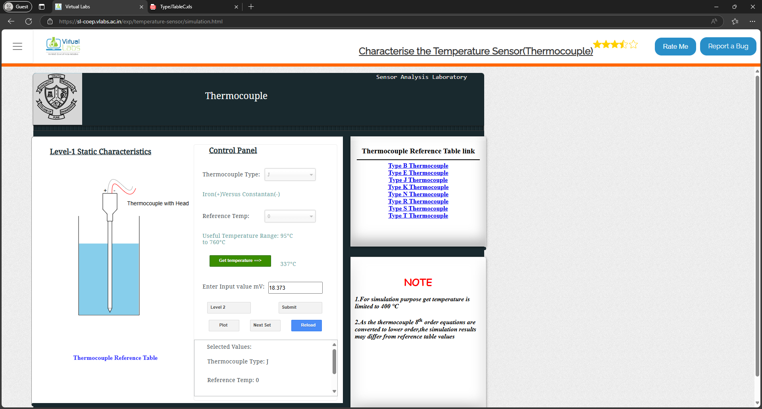

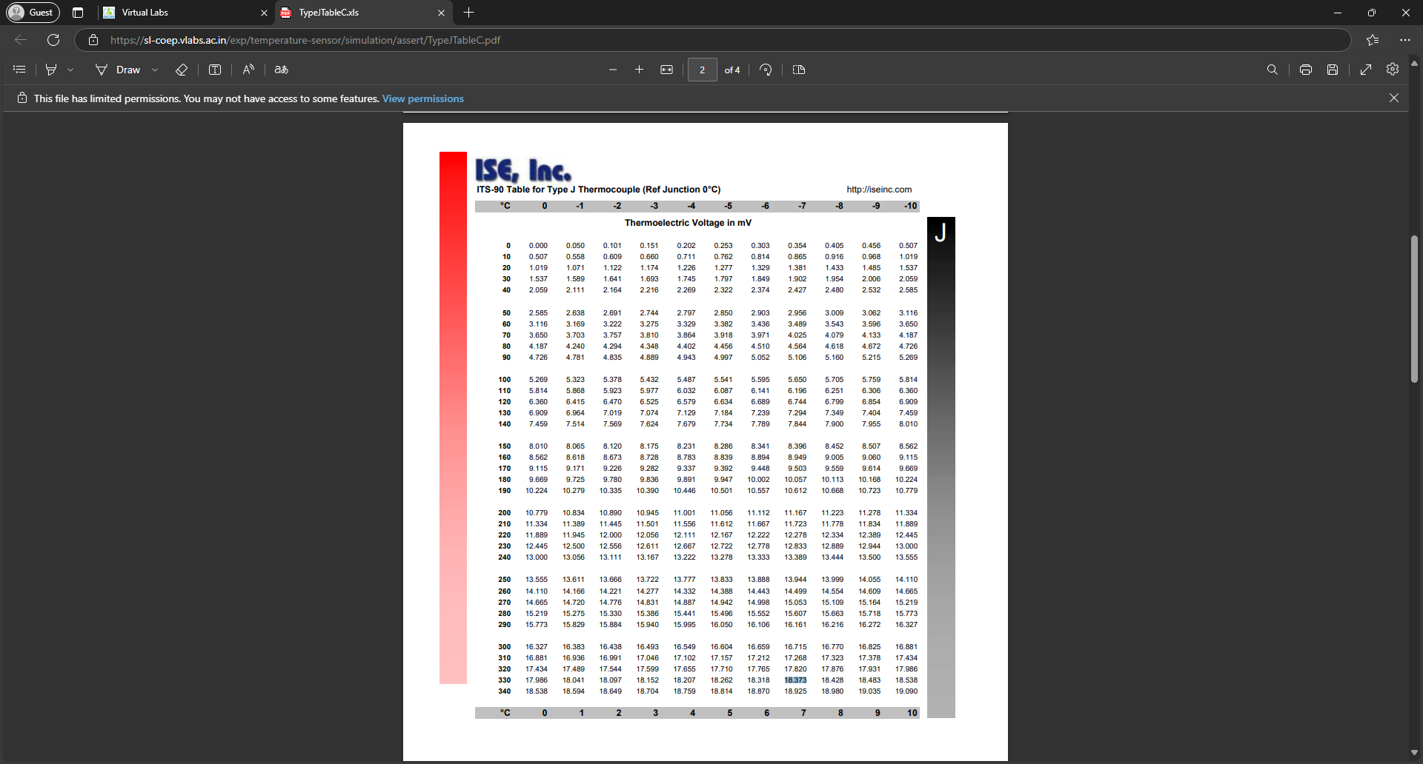

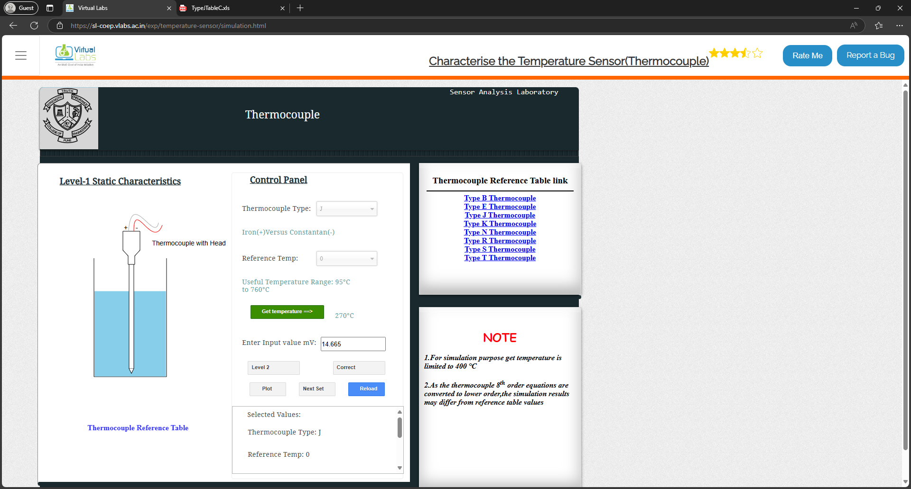

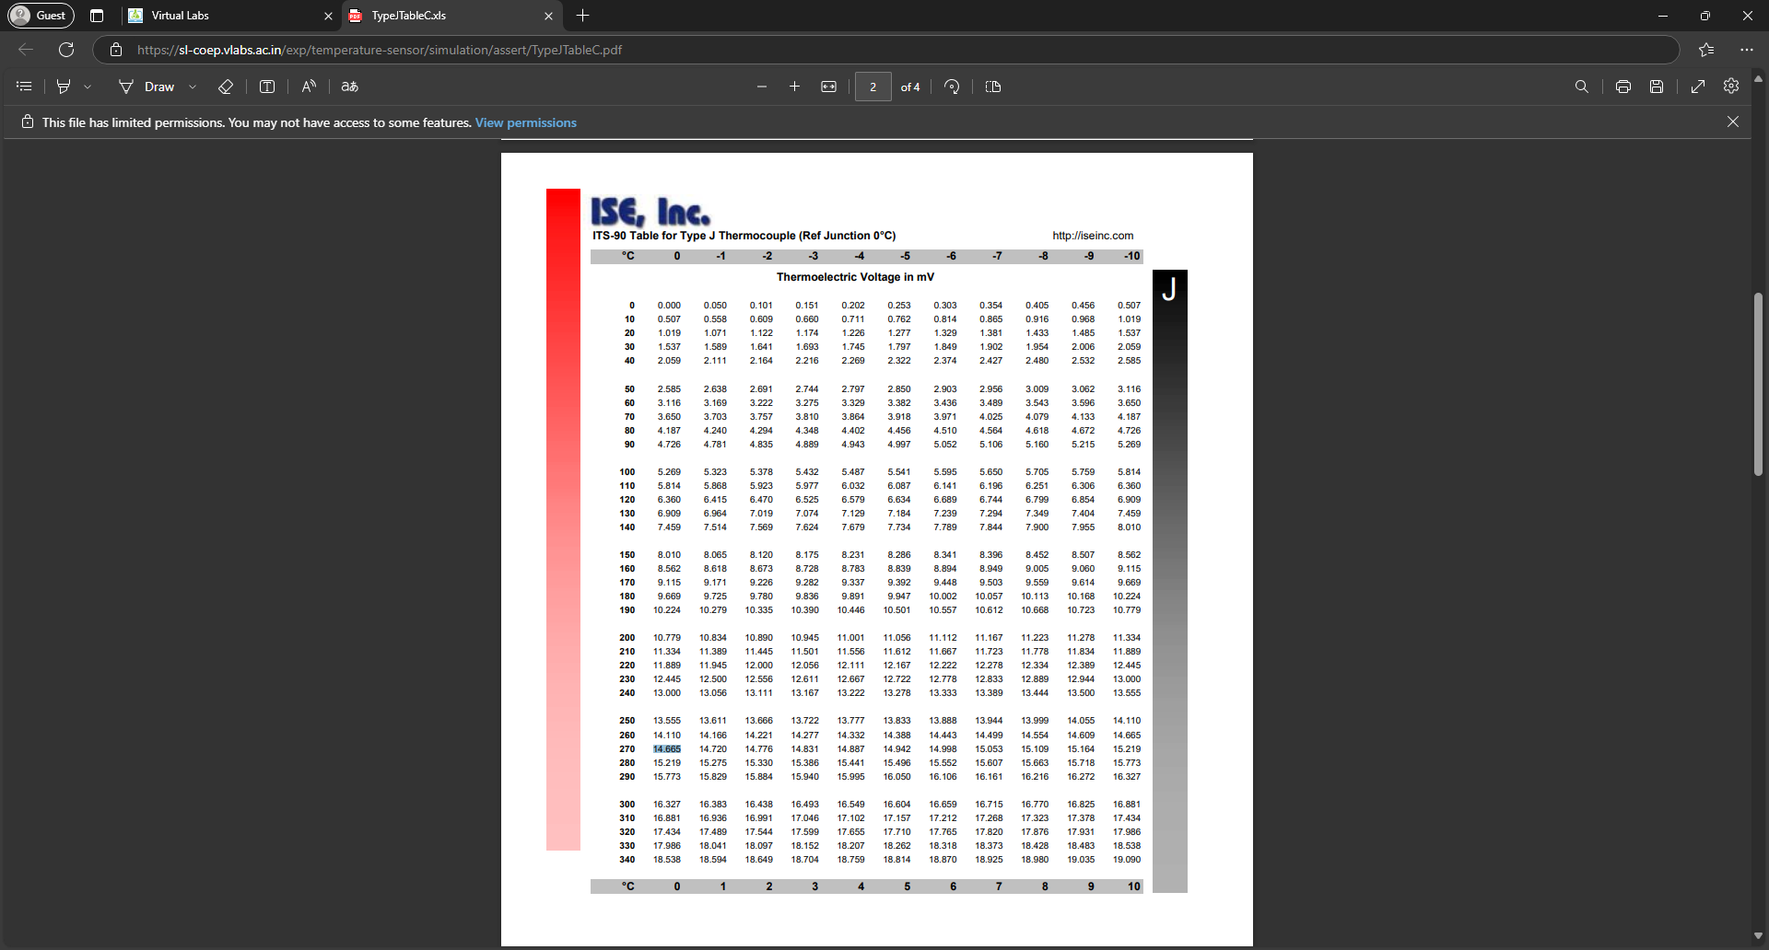

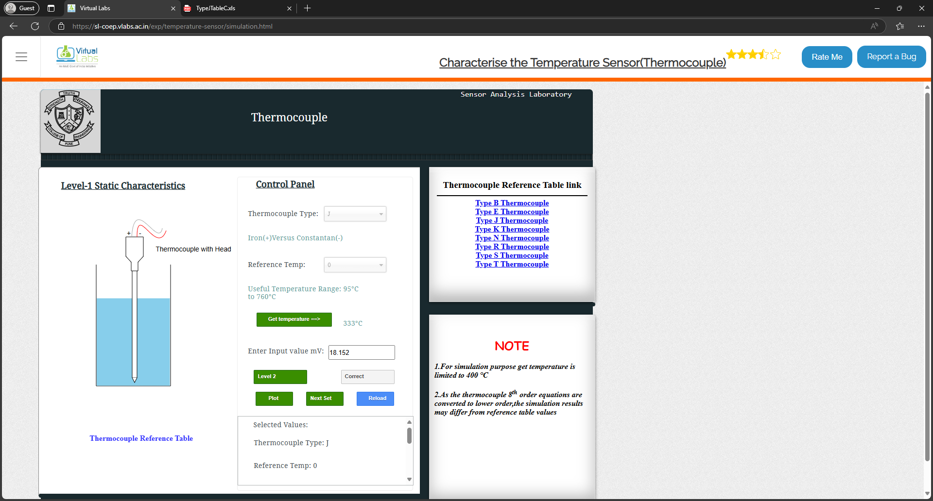

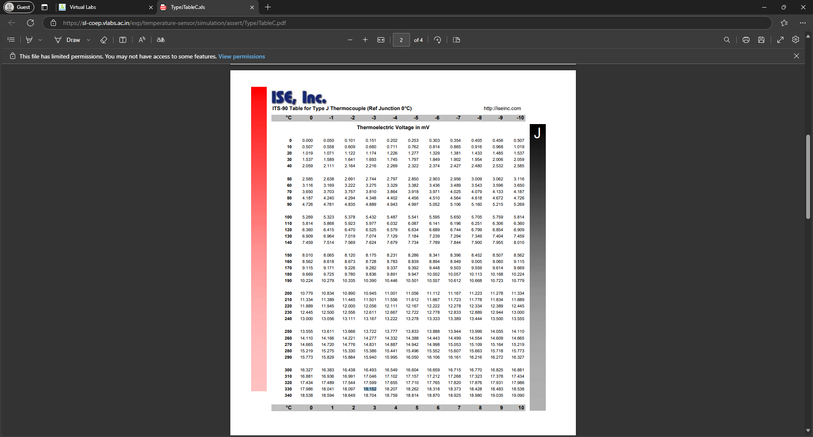

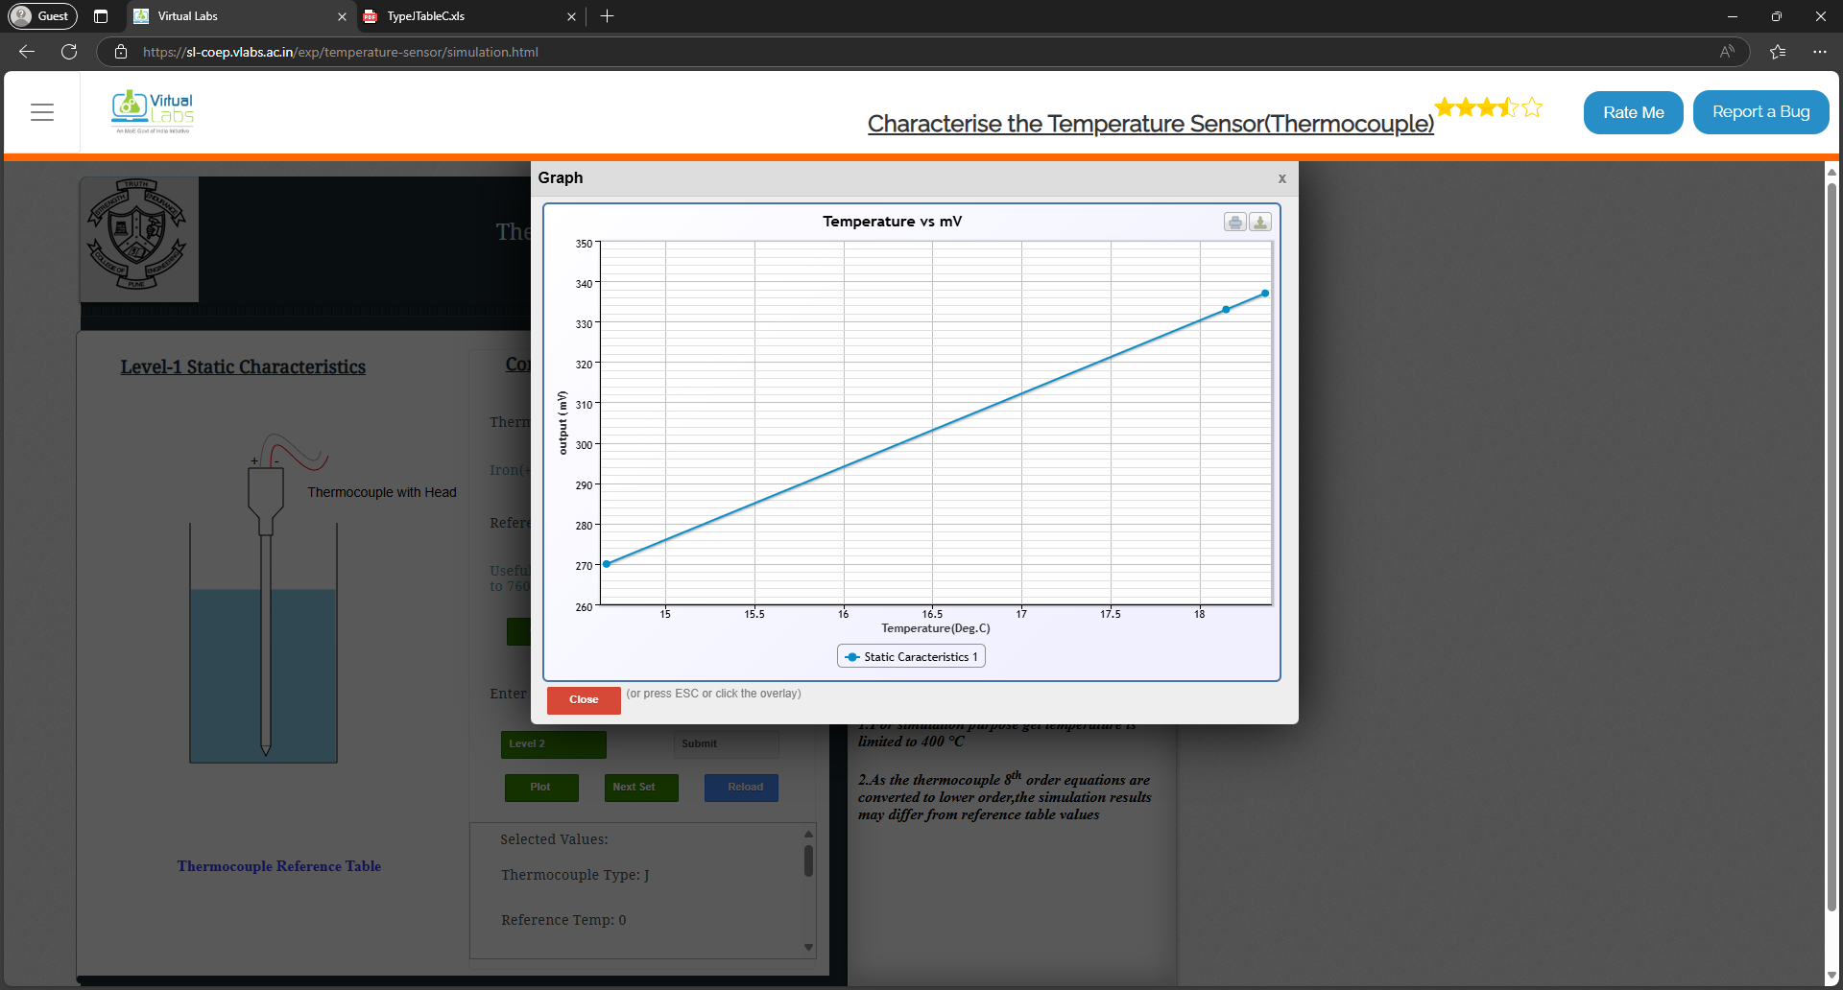

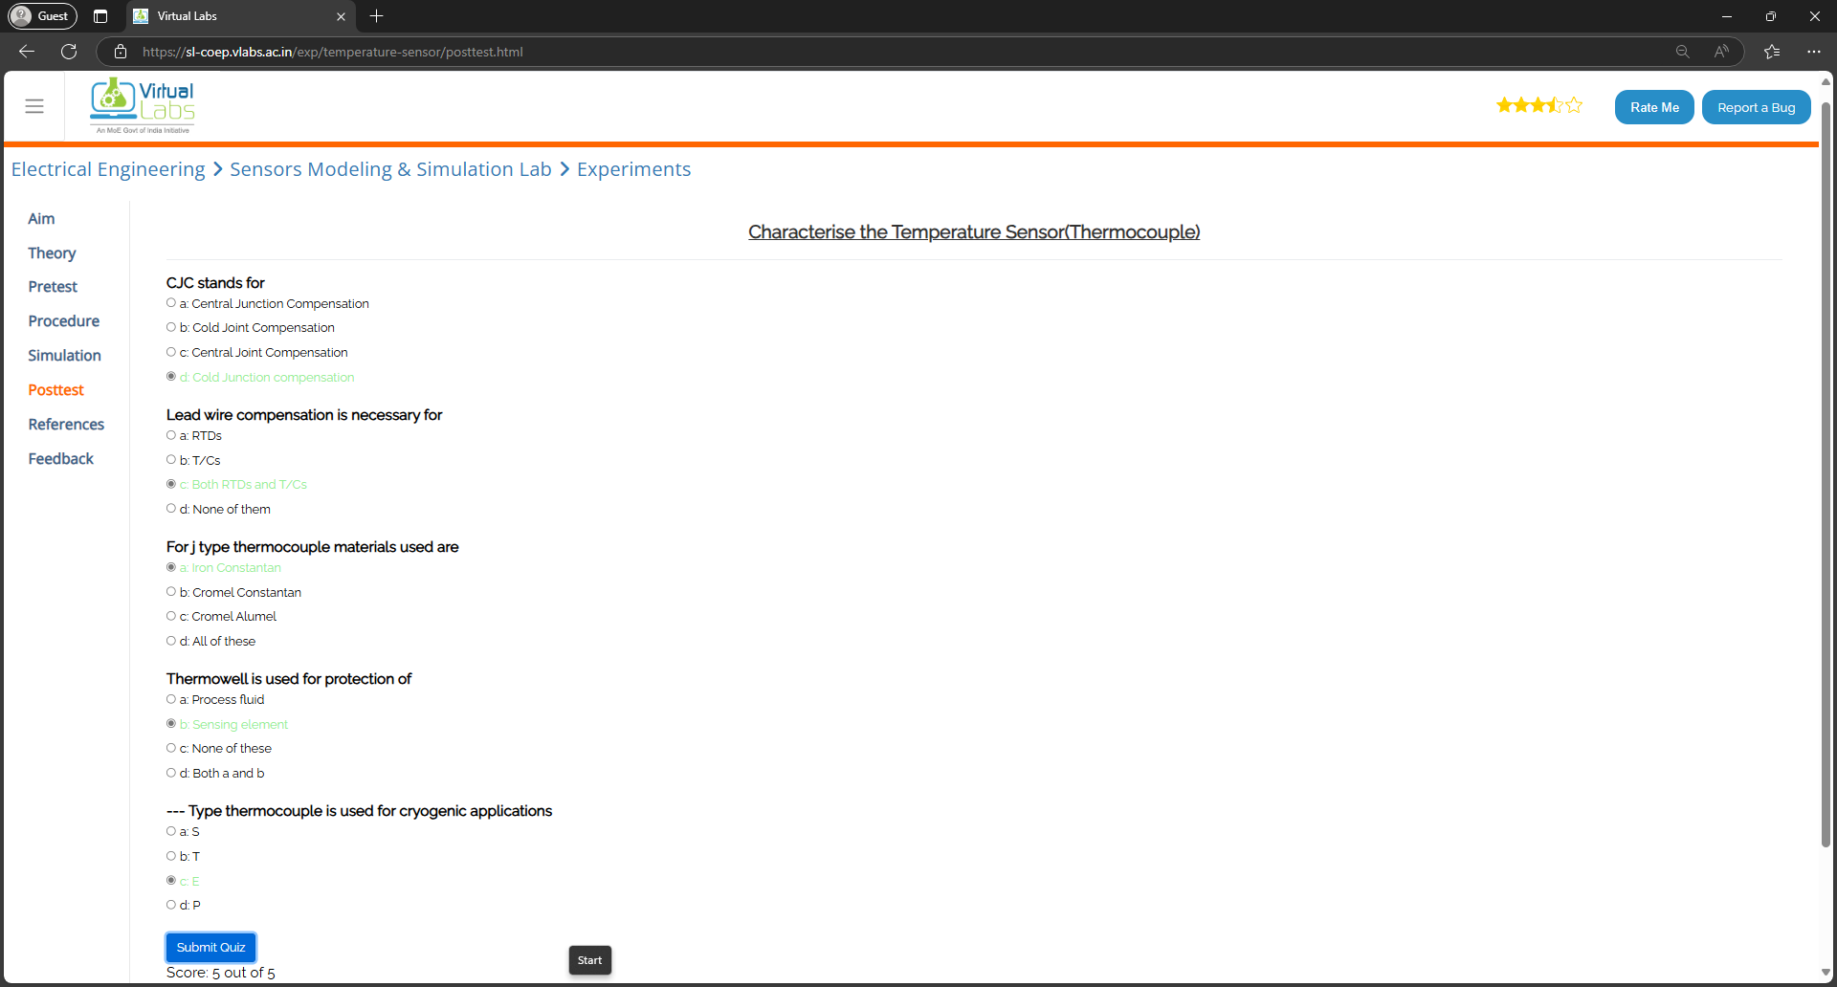

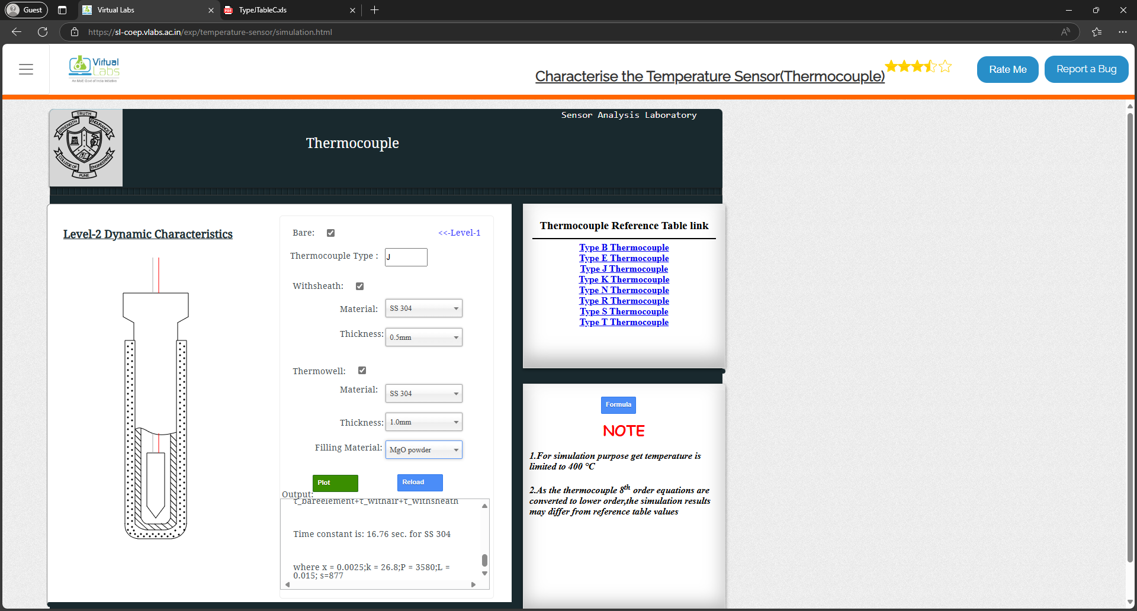

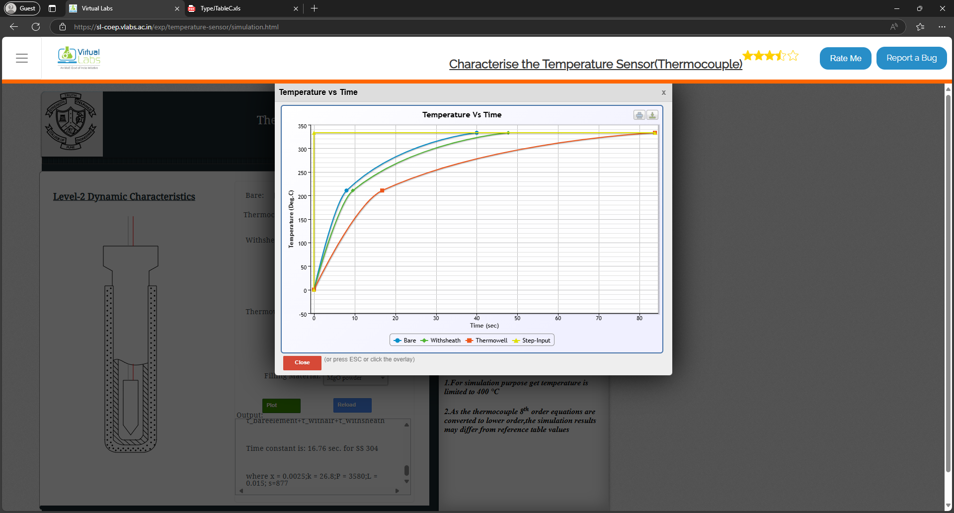

**Questions:**

**1. Explain AWS IoT Greengrass concept.**

AWS IoT Greengrass is a service that extends AWS cloud capabilities to local devices, allowing them to process data, execute machine learning models, and communicate securely even when offline. It enables edge devices to act intelligently by running AWS Lambda functions, synchronizing data with the cloud, and securely interacting with other devices in the network.

**Key features of AWS IoT Greengrass:**

**i. Local Computing:** Allows devices to process data locally without always depending on the cloud.

**ii. Machine Learning (ML) Inference:** Enables edge devices to run pre-trained ML models for faster decision-making.

**iii. Secure Device Communication:** Provides authentication and encryption for secure device-to-device and device-to-cloud communication.

**iv. Connectivity Management:** Supports intermittent connectivity by caching messages and synchronizing them with the cloud when the connection is restored.

**v. Lambda Function Execution:** Allows running AWS Lambda functions on local devices to automate tasks and respond to local events.

AWS IoT Greengrass is widely used in industries like smart homes, industrial automation, and healthcare to improve efficiency and reduce latency in IoT applications.

**Outcomes: CO2 — Comprehend IoT architecture, enabling technologies and protocols**

**Conclusion:**

In this experiment, we explored the concept of Virtual Labs and how they enable remote experimentation in IoT. The selected experiment demonstrated the functionality of a temperature sensor using a virtual simulation. The use of Virtual Labs enhances learning by providing hands-on experience without requiring physical hardware. Additionally, we learned about AWS IoT Greengrass and its role in enabling edge computing for IoT devices, allowing them to process data locally while maintaining secure communication with the cloud. This knowledge is essential for developing efficient and scalable IoT applications.

**Grade: AA / AB / BB / BC / CC / CD / DD**

**Signature of faculty in-charge with date**

**References:**

**Links:**

<https://www.vlab.co.in/>

**Books:**

1. Jan Holler, Vlasios Tsiatsis, Catherine Mulligan, Stefan Avesand, Stamatis Karnouskos, David Boyle, “From Machine-to-Machine to the Internet of Things: Introduction to a New Age of Intelligence”, 1st Edition, Academic Press, 2014.

2. Vijay Madisetti and Arshdeep Bahga, “Internet of Things (A Hands-on-Approach)”, 1stEdition, VPT, 2014.

3. Dr. Ovidiu Vermesan, Dr. Peter Friess, “Internet of Things - From Research and Innovation to Market Deployment”, River Publisher, 2014